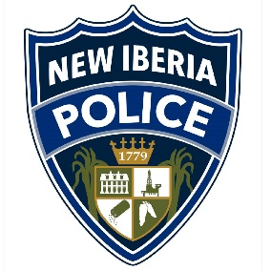
New Iberia Police Department
457 E Main St
New Iberia, LA 70560
Non-Emergency Number: (337) 369-2306
Records: (337) 369-2307

CAD Notification Request Form

The New Iberia Police Department uses a Computer-Aided Dispatch System that has the capability to flag any particular address with important information that can be beneficial to first responders. Examples: young children that live in the home with medical conditions, oxygen equipment on site, physical disabilities, etc. The NIPD Communications Officers can relay this information to first responders upon dispatch so that responders are aware before they arrive.

The following is your personal contact information in case we need to reach you:
Full Name | First Name Last Name
Mailing Address | House Number Apt/Lot# Street Name
 | City State Zip Code
Phone Number(s) | Home ( ) - Cell ( ) - Work ( ) -
Email

Address that needs to be flagged within the CAD system, if different from above. Address has to be inside of Iberia Parish:
House Number Apt/Lot# Street Name

City State Zip Code

Explanation and details of what you want first responders to know - Please include full names and ages of individuals who reside in the home. Include medical disabilities, limitations, hazardous materials on site, etc.

Submit form(s) to:
Michele Conroy – Communications Center Supervisor
457 E Main St. Suite 100
New Iberia, LA 70560
Office: (337) 251-8143
Fax: (337) 608-8158
Email: mconroy@newiberiapolice.com
Forms can be sent in by email, fax, or postal mail.

